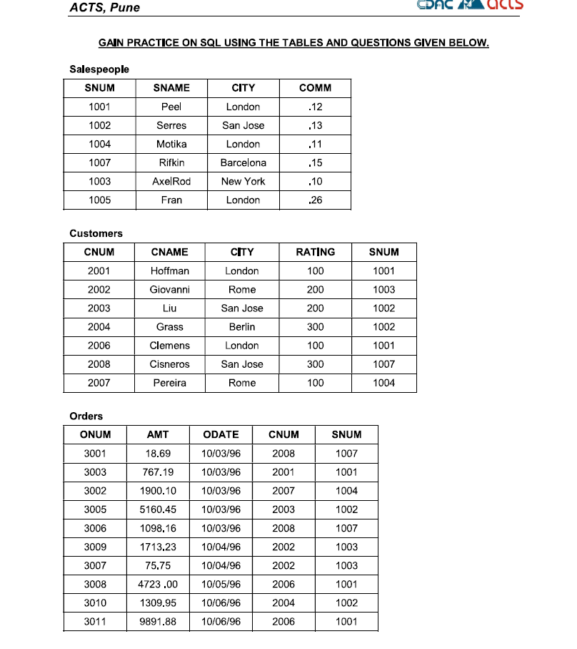

--6. Find which salespeople currently have orders in the Orders table
-- 7. List names of all customers matched with the salespeople serving them
-- 8. Find the names and numbers of all salespeople who had more than one customer
-- 9. Count the orders of each of the salespeople and output the results in descending order
--10 Count the orders of each of the salespeople and output the results in descending order
-- 11. Match salespeople to customers according to the city they lived in
-- 12. List all the orders of salesperson Motika from the Orders table
-- 13. Find all customers with orders on October 3
-- 14. Find all pairs of customers having the same rating
-- 15 List the largest orders for October 3, for each salesperson
-- 16. Write a query that produces all customers serviced by salespeople with a commission above 12%. Output the customer's name and the salesperson's rate of commission.

